**Winter 2017 Dewey Diva Picks**

**Ampersand**

**Books for Kids**

* 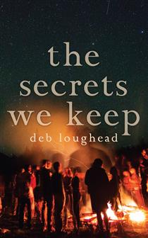 ***The Secrets We Keep* by Deb Loughead - Dundurn – 9781459737297 – TP – $12.99 – Juvenile Fiction – 184 pp. – December 2016**

When Kit disappeared at a party and was found drowned in the quarry the next day, Clem knew who to point the finger at: herself. She was the last person to see him alive. If she had just kept a closer eye on him instead of her crush, Jake, maybe Kit would still be here. She knows she made a mistake, and wishes she could just forget about it — but Clem’s friend Ellie says she’ll expose Clem’s secret if she doesn’t play along with Ellie’s lies.

* 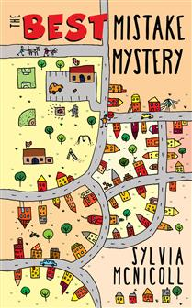***The Best Mistake Mystery* by Sylvia McNicoll – Dundurn – 9781459736252 – TP – $8.99 – Juvenile Fiction – 160 pp. – January 2017**

Dogwalker extraordinaire Stephen Nobel can get a little anxious, but his habit of counting the mistakes he and everyone else makes calms him. His need to analyze gets kicked into hyperdrive after two crazy events happen in one day at school: the bomb squad blows up a backpack and someone smashes a car into the building. To make things worse, that someone thinks Stephen can identify them. Stephen receives a threatening text. If he goes to the police, his favourite dogs, Ping and Pong, will get hurt.

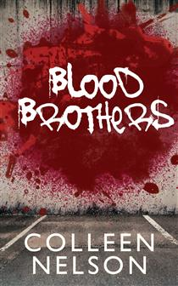

* ***Blood Brothers* by Colleen Nelson - Dundurn – 9781459737464 – TP – $12.99 – Juvenile Fiction – 240 pp. – February 2017**

When Jakub gets a scholarship to an elite private school, he knows it’s his chance for a better life. But it means leaving Lincoln and the neighbourhood he calls home. While Jakub’s future is looking bright, Lincoln’s gets shady as he is lured into his brother’s gang. Jakub watches helplessly as Lincoln gets pulled deeper into the violent world of the Red Bloodz. The Red Bloodz find out Jakub knows more than he should about a murder and want him silenced — for good. Lincoln has to either save his friend, or embrace life as one of the Red Bloodz.

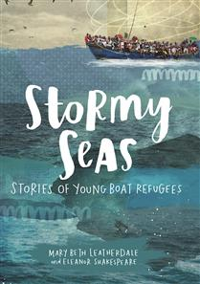

* ***Stormy Seas* by Mary Beth Leatherdale – Annick Press – 9781554518968 – HC – $24.95 – Juvenile Nonfiction – 64 pp. – April 2017**

A treacherous voyage across the open seas is the last hope for safety and freedom for five young people from around the world. The phenomenon of desperate refugees risking their lives to reach safety is not new. For hundreds of years, people have left behind family, friends, and all they know in hope of a better life. This book presents five true stories about young people who lived through the harrowing experience of setting sail in search of asylum.

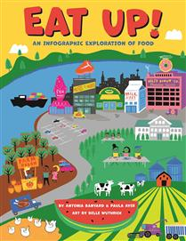

* ***Eat Up* by Paula Ayer – Annick Press – 9781554518845 – HC – $22.95 – Juvenile Nonfiction – 72 pp. – April 2017**

Filled with fascinating facts delivered visually, this infographic book explores the topic of food from every aspect. Written for middle-grade readers, Eat Up! is a colorful infographic look at the many surprising and fascinating facts about food. Information is presented in easy-to-understand graphics and clear explanations. Each spread explores a different aspect of the topic.

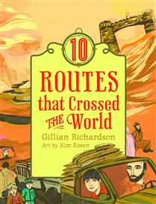

* ***10 Routes That Crossed the World* by Gillian Richardson – Annick – 9781554518760 – HC – $24.95 – Juvenile Nonfiction – 164 pp. – April 2017**

Vivid storytelling brings to life the pathways of world history. Written for middle-grade readers, 10 Routes That Crossed the World explores famous roads, trails, and pathways across the globe that have played a significant role in human history.

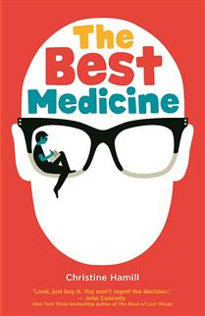

***The Best Medicine* by Christine Hamill – Annick – 9781554518807 – HC – $18.95 – Juvenile Fiction – 204 pp. – March 2017**

Philip’s happy-go-lucky life is disrupted when his mother gets breast cancer. Bad enough that your mother is seriously ill – but could she not have developed a less embarrassing kind of cancer – toe cancer, maybe, or ear cancer? Philip’s attempts to cope with his situation are both hilarious and touching amidst his confusion and bewilderment.

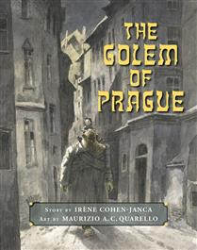

***The Golem of Prague* by Irène Cohen-Janca – Annick – 9781554518883 – HC – $24.95 – Juvenile Fiction – 52 pp. – March 2017**

This retelling of an ancient Jewish legend will capture a new audience with its powerful illustrations and timeless text. This beautiful picture book with its lyrical text and evocative illustrations, retells the story of the Golem through the eyes of a young boy, Frantz.

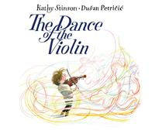

* ***The Dance of the Violin* by Kathy Stinson – Annick – 9781554519002 – HC – $19.95 – Juvenile Fiction – 32 pp. – March 2017**

Duan Petricic’s brilliant illustrations full of movement and color, capture the sounds made by Joshua’s violin, from the missed notes to the swirling, uplifting strains of the perfectly executed piece. Children will readily empathize with Joshua’s misstep, but they will also learn that there is always a second chance.

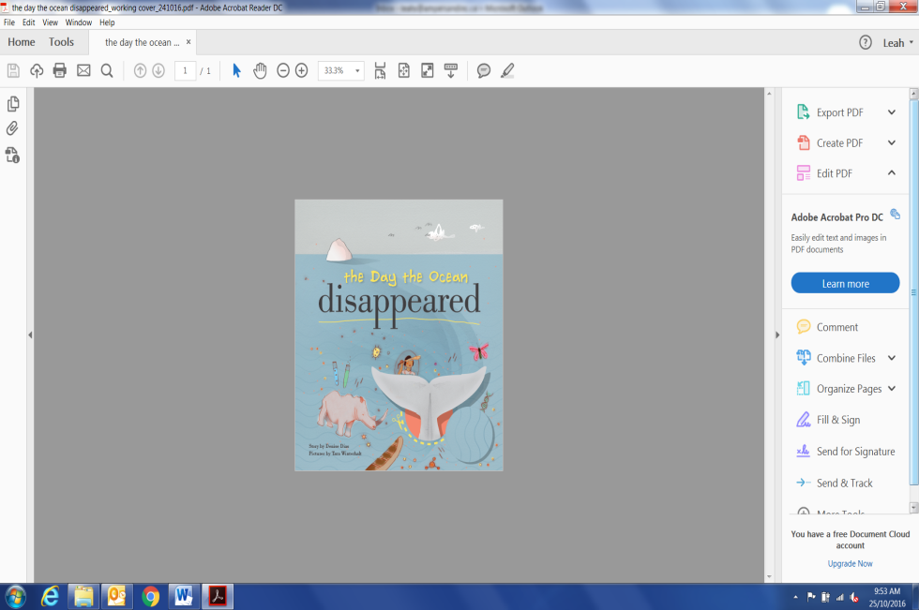***The Day the Ocean Disappeared* by Denise Dias – Royal Ontario Museum – 9780888545183 – HC – $16.95 – Juvenile Fiction – 32 pp. – March 2017**

The book follows a young whale on a journey of self-discovery as she accidentally ends up at the ROM. Through her visit, she learns about her history and why she is special. The children`s book is an entertaining and adventurous tale aimed to teach its young audience about the importance of blue whales while highlighting environmental issues such as species endangerment.

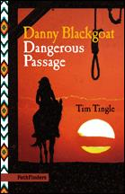

***Danny Blackgoat: Dangerous Passage* by Tim Tingle – Book Publishing Co – 9781939053152 – TP – $12.95 – Juvenile Fiction – 162 pp. – March 2017**

During the Civil War, the United States Army imprisoned thousands of Navajos in unsafe conditions at Fort Sumner. Through the eyes of teenager Danny Blackgoat, readers experience how the Diné people struggled to survive. In the concluding novel of the Danny Blackgoat trilogy, the major characters appear in a final scene of reckoning.

***Where Will I Live?* by United Nations High Commissioner for Refugees – Second Story Press – 9781772600285 – HC – $19.95 – Juvenile Nonfiction – 24 pp. – April 2017**

This stunning photo-based picture book for younger readers takes a look at the thousands of children around the world who have been forced to flee war, terror, hunger, sickness, and natural disasters — young refugees on the move with very little left except questions. It’s hard to imagine, but the images here will help unaffected children understand not only what this must feel like, but also how very lucky they are.

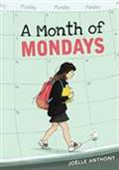

* ***A Month of Mondays* by Joëlle Anthony - Second Story Press – 9781772600261 – TP – $10.95 – Juvenile Fiction – 208 pp. – March 2017**

Suze Tamaki's life gets turned upside down when her mother suddenly reappears after a ten-year absence. Once Suze gets over her initial cynicism, she thinks it might be cool to get to know her mom. But her older sister Tracie – who has been as much mother as sister at times – is determined to make Suze’s life a misery for even considering it.

* 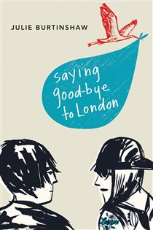 ***Saying Good-bye to London* by Julie Burtinshaw – Second Story Press – 9781772600292 – TP – $12.95 – Juvenile Fiction – 236 pp. – March 2017**

Francis Sloan is a shy fifteen-year-old boy. When he meets edgy sixteen-year-old Sawyer, sparks fly… and Sawyer becomes pregnant. They they decide they will put the baby up for adoption – and be instrumental in choosing the adoptive parents. As the story unfolds over the nine months they wait for baby London to be born, Francis and Sawyer grapple with the responsibility they feel toward their child and the accelerated path to adulthood they now find themselves on.

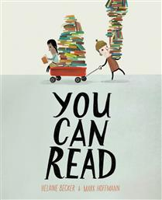

* ***You Can Read* by Helaine Becker - Orca – 9781459813243 – HC – $19.95 – Juvenile Fiction – 32 pp. – February 2017**

In this fun and funny celebration of literacy, kids of all ages will discover that the act of reading is a daring adventure that can take you anywhere! You can read at the playground, under the sea, at the opera and even in outer space! It turns out you can read everywhere! And when you do, you open yourself to a universe of adventure.

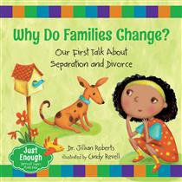

* ***Why Do Families Change?* by Jillian Roberts – Orca – 9781459809512 – HC – $19.95 – Juvenile Nonfiction – 32 pp. – March 2017**

Separation and divorce are difficult on the entire family. Often young children blame themselves or are unsure of their place in the family if these events occur. Child psychologist Dr. Jillian Roberts designed the Just Enough series to empower parents/caregivers to start conversations with young ones about difficult or challenging subject matter.

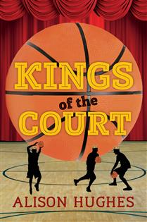

* ***Kings of the Court* by Alison Hughes – Orca – 9781459812192 – TP – $9.95 – Juvenile Fiction – 192 pp. – March 2017**

When the Gladiators basketball team's nasty coach finally gets turfed midseason, things couldn't possibly get worse. The team hasn't won a game yet, and morale is at rock bottom. Sameer, who announces the games and keeps score, and Vijay, the team mascot, have their hands full keeping the team's spirits up. When they get promoted to assistant coach and manager, can they help a small, unathletic, Shakespeare-quoting drama teacher coach the team to victory, or at least to dignity?

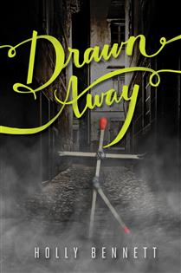

* ***Drawn Away* by Holly Bennett – Orca – 9781459812529 – HC – $19.95 – Juvenile Fiction – 208 pp. – January 2017**

One minute Jack's in math class. The next, he's on a dark, cobblestoned, empty street. Empty, that is, except for a skinny girl wrapped in a threadbare shawl. "Matches, mister?" she asks, and just like that, Jack's life collides with one of Hans Christian Andersen's grimmest tales. And just when he has almost convinced himself it was just a weird dream, it happens again. Suddenly, Jack's ideas about what is "real" or "possible" no longer apply.

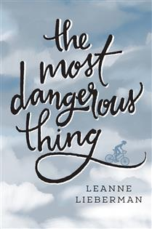

* ***The Most Dangerous Thing* by Leanne Lieberman – Orca – 9781459811843 – TP – $14.95 – Juvenile Fiction – 240 pp. – March 2017**

Sixteen-year-old Sydney hates to talk (or even think) about sex. She's also fighting a secret battle against depression, and she's sure she'll never have a boyfriend. When her classmate Paul starts texting and sending her nature photos, she is caught off guard by his interest.

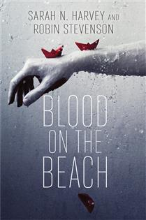

* ***Blood on the Beach* by Sarah N. Harvey – Orca – 9781459812932 – TP – $14.95 – Juvenile Fiction – 272 pp. – March 2017**

Eight teens are dropped off on a remote west-coast island for a week-long treatment program called INTRO (Into Nature to Renew Ourselves). The story is told by two of them: Alice, whose police-officer mother believes Alice might have a substance-abuse problem, and Caleb, who assaulted his abusive stepfather.

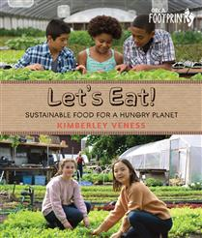

* ***Let's Eat* by Kimberley Veness – Orca – 9781459809390 – HC – $19.95 – Juvenile Nonfiction – 48 pp. – February 2017**

All the food you eat, whether it's an apple or a steak or a chocolate-coated cricket, has a story. Let's Eat uncovers the secret lives of our groceries, exploring alternative—and sometimes bizarre—farm technology and touring gardens up high on corporate rooftops and down low in military-style bunkers beneath city streets.



* ***Birthdays* by Nikki Tate – Orca – 9781459812970 – HC – $24.95 – Juvenile Nonfiction – 80 pp. – March 2017**

Inspired by memories of fantastic family birthday parties, mother-and-daughter team Nikki Tate and Dani Tate-Stratton researched the history of birthdays in order to answer such questions as, How much does where you grow up influence the way you celebrate getting a year older?

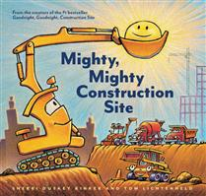***Mighty, Mighty Construction Site* by Sherri Duskey Rinker – Chronicle Books – 9781452152165 – HC – $23.99 – Juvenile Fiction – 40 pp. – February 2017**

Down in the big construction site, tough trucks stir in the morning light! They’re eager to get things underway. There's a brand-new job to start today . . . but this new job is the biggest they’ve ever seen, and Excavator, Bulldozer, Crane Truck, Dump Truck, and Cement Mixer will need the help of new construction friends to get it done.

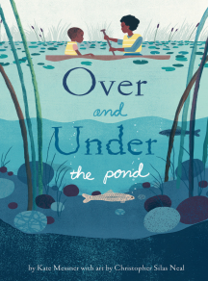***Over and Under the Pond* by Kate Messner – Chronicle Books – 9781452145426 – HC – $23.99 – Juvenile Nonfiction – 48 pp. – March 2017**

A follow up to Over and Under the Snow and Up in the Garden and Down in the Dirt, this time focusing on the rich, interconnected ecosystem of a mountain pond. As parent and child launch a canoe from the muddy shore and paddle through water lilies, they see frogs jump and painted turtles slide off logs, disappearing beneath the murky water. What’s happening down there?

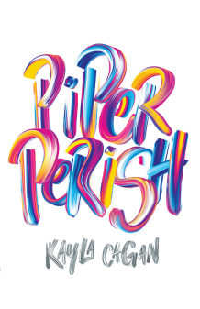

***Piper Perish* by Kayla Cagan - Chronicle Books – 9781452155838 – HC – $24.99 – Juvenile Fiction – 416 pp. – March 2017**

In this ridiculously propulsive, utterly authentic work from debut author Kayla Cagan, the unprecedented Piper Perish is realer than real. Breathing new life into fiction, Piper will have readers asking big questions along with her. What is love? What is friendship? What is family? What is home? And who is a person when she?s missing any one of these things?

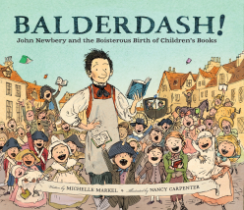***Balderdash!* by Michelle Markel – Chronicle Books – 9780811879224 – HC – $24.99 – Juvenile Nonfiction – 44 pp. – April 2017**

A picture book biography about John Newbery, pioneering author and publisher for whom the prestigious Newbery medal is named, and the revolution in children's books that he led.

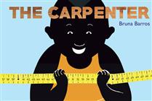***The Carpenter* by Bruna Barros - Gibbs Smith – 9781423646761 – HC – $17.99 – Juvenile Fiction – 40 pp. – February 2017**

This special book shares its story without a single word. Bruna Barros’ beautiful, creative illustrations will capture children’s imaginations, showing readers that even the simplest, most common objects can start a wonderful adventure. This book also offers opportunities to foster discussions and spontaneous story telling.

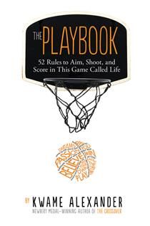

***The Playbook* by Kwame Alexander – Houghton Mifflin Harcourt – 9780544570979 – HC – $20.99 – Juvenile Nonfiction – 176 pp. – February 2017**

Illustrated with photographs by Thai Neave, The Playbook is intended to provide inspiration for kids ages ten and up to help them succeed on and off the court. Each rule contains wisdom from inspiring athletes and role models such as Nelson Mandela, Serena Williams, LeBron James, Carli Lloyd, Steph Curry and Michelle Obama. Kwame Alexander also provides his own words of inspiration and uplift, as he shares his stories of overcoming obstacles and winning games.

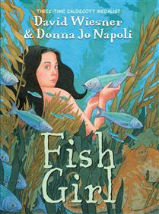

***Fish Girl* by David Wiesner – Houghton Mifflin Harcourt – 9780544815124 – HC – $35.50 – Juvenile Fiction – 192 pp. – March 2017**

The triple Caldecott winner David Wiesner brings his rich visual imagination and trademark artistry to the graphic novel format in a unique coming-of-age tale that begins underwater. A young mermaid, called Fish Girl, in a boardwalk aquarium has a chance encounter with an ordinary girl. Their growing friendship inspires Fish Girl's longing for freedom, independence, and a life beyond the aquarium tank.

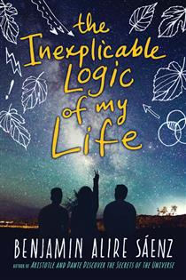

***The Inexplicable Logic of My Life* by Benjamin Alire Saenz – Houghton Mifflin Harcourt – 9780544586505 – HC – $24.99 – Juvenile Fiction – 464 pp. – March 2017**

Sal used to know his place with his adoptive gay father, their loving Mexican American family, and his best friend, Samantha. But it’s senior year, and suddenly Sal is throwing punches, questioning everything, and realizing he no longer knows himself. If Sal’s not who he thought he was, who is he? This humor-infused, warmly humane look at universal questions of belonging is a triumph.

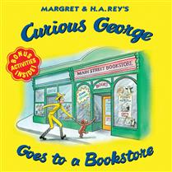***Curious George Goes to a Bookstore* by H. A. Rey – Houghton Mifflin Harcourt – 9780544932043 – TP – $6.99 – Juvenile Fiction – 24 pp. – March 2017**

George’s favorite author is doing a signing at the new bookstore in town. Waiting in line is hard when you’re as curious as our little monkey, especially when surrounded by so many great books! Children will love his silly antics as George explores the wonderful world that is the local bookstore.

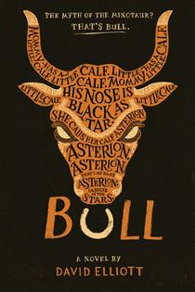

***Bull* by David Elliott – Houghton Mifflin Harcourt – 9780544610606 – HC – $24.99 – Juvenile Fiction – 200 pp. – March 2017**

Much like Lin-Manuel Miranda did in *Hamilton*, the New York Times best-selling author David Elliott turns a classic on its head in form and approach, updating the timeless story of Theseus and the Minotaur for a new generation. A rough, rowdy, and darkly comedic young adult retelling in verse, Bull will have readers re-evaluating one of mythology's most infamous monsters.

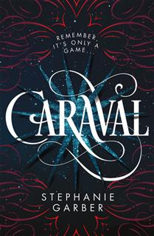

***Caraval* by Stephanie Garber – Flatiron Books – 9781250095251 – HC – $26.99 – Juvenile Fiction – 416 pp. – January 2017**

Scarlett has never left the tiny island where she and her beloved sister, Tella, live with their powerful, and cruel, father. Now Scarlett’s father has arranged a marriage for her, and Scarlett thinks her dreams of seeing Caraval, the far-away, once-a-year performance where the audience participates in the show, are over. But this year, Scarlett’s long-dreamt of invitation finally arrives. With the help of a mysterious sailor, Tella whisks Scarlett away to the show.

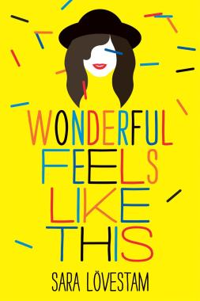***Wonderful Feels Like This* by Sara Lovestam – Flatiron Books – 9781250095237 – HC – $24.99 – Juvenile Fiction – 320 pp. – March 2017**

For Steffi, going to school everyday is an exercise in survival. She's never fit in with any of the groups at school, and she's viciously teased by the other girls in her class. The only way she escapes is through her music—especially jazz music.

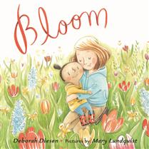 ***Bloom* by Deborah Diesen – Farrar Straus & Giroux – 9780374302504 – HC – $23.99 – Juvenile Fiction – 32 pp. – March 2017**

In this lushly illustrated story that celebrates life and growing up, a mother and daughter plant a garden to see how something small blooms into something as beautiful and strong as their love.

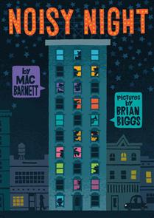 ***Noisy Night* by Mac Barnett – Roaring Brook Press – 9781596439672 – HC – $23.99 – Juvenile Fiction – 32 pp. – March 2017**

It's a noisy night in this city building! The residents of each floor can hear their neighbors above them, and are wondering what's going on above their heads. Climb floor by floor and page by page to find out whose singing, dancing, cheering, and cooing are keeping a grumpy old man awake.

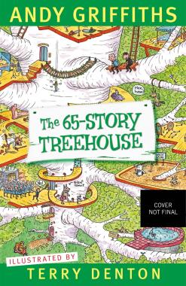 ***The 65-Story Treehouse* by Andy Griffiths - Feiwel & Friends – 9781250102461 – HC – $19.50 – Juvenile Fiction – 384 pp. – April 2017**

Andy and Terry live in a 65-Story Treehouse. (It used to be 52 stories, but they keep expanding.) It has a pet-grooming salon, a birthday room where it's always your birthday (even when it's not), a room full of exploding eyeballs, a lollipop shop, a quicksand pit, an ant farm, and a time machine...which is going to be really, really useful now, since Terry messed up (again) and the treehouse just FAILED it's safety inspection. Join Andy and Terry on a whirlwind trip through time as they try to stop the treehouse from being demolished!

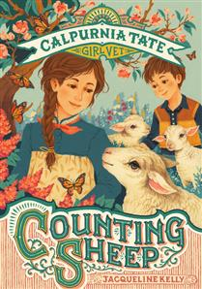 ***Counting Sheep: Calpurnia Tate, Girl Vet* by Jacqueline Kelly – Henry Holt and Co. – 9781627798709 – HC – $22.99 – Juvenile Fiction – 112 pp. – April 2017**

In this second book in the Calpurnia Tate, Girl Vet series, Callie takes a hands-on approach to animal doctoring. When Callie and Granddaddy go exploring by the river, Callie discovers a leaf covered with spots. Those spots, it turns out, are eggs, and those eggs become butterflies. One of her newly hatched butterflies has a problem, though—its wing is broken. Can Callie find a way to help this butterfly fly?

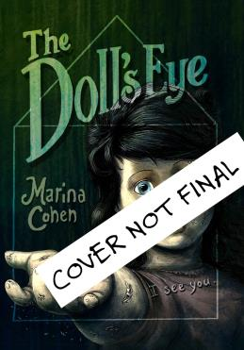 ***The Doll's Eye* by Marina Cohen - Roaring Brook Press – 9781626722040 – HC – $23.99 – Juvenile Fiction – 208 pp. – February 2017**

As Hadley whiles away what’s left of her summer, she begins to notice the house isn’t just old and creaky. It’s full of secrets, just like appearance of a mysterious dollhouse and the family of perfect dolls she finds.Oh, how she wishes her family were more like those lovely dolls! Then one day, Hadley discovers a lone glass eye rolling around the floor of the attic. Holding it close one night, she makes a wish that just might change her world forever.

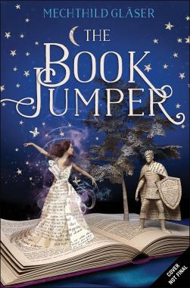 ***The Book Jumper* by Mechthild Glaser – Feiwel & Friends – 9781250086662 – HC – $24.99 – Juvenile Fiction – 384 pp. – January 2017**

Amy is a book jumper, able to leap into a story and interact with the world inside. As thrilling as Amy's new power is, it also brings danger: someone is stealing from the books she visits, and that person may be after her life. Teaming up with fellow book jumper Will, Amy vows to get to the bottom of the thefts—at whatever cost.

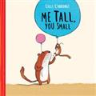

* [**Me Tall, You Small**](https://bnccatalist.ca/ViewTitle.aspx?id=6327749) **by Lilli L'Arronge – Owlkids – 9781771471947 – HC - $18.95 - Juvenile Fiction - 40 PP. Mar 2017**

*Me Tall, You Small* is a series of playful vignettes in the daily life of a pair of weasels, parent and child. Whether they are having a bubble bath, kicking a soccer ball, or eating ice cream together, simple paired phrases showcase their loving—and amusingly realistic—relationship. After a fall: *You boo-boo. Me bandage.* At bedtime: *Me tired. You wired.*

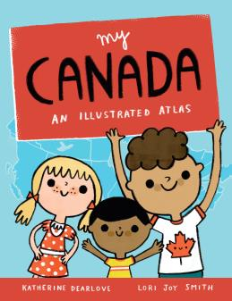

* [**My Canada**](https://bnccatalist.ca/ViewTitle.aspx?id=6327751) **An Illustrated Atlas by Katherine Dearlove – Owlkids – 9781771472647 -HC- $18.67 - Juvenile Nonfiction - 32 PP. May 2017**

This picture book atlas of Canada is a whimsical, informative introduction to our country from sea to sea to sea. Each province and territory is featured on its own spread, with icons and labels indicating the capital city, other major cities, key lakes and rivers, iconic landmarks, animals, and plants, significant national and provincial parks, and more.

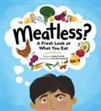

* [**Meatless?**](https://bnccatalist.ca/ViewTitle.aspx?id=6327759) **A Fresh Look at What You by Eat Sarah Elton -Owlkids- 9781926818436 - $18.95 - JUVENILE NONFICTION 48 PP. May 2017**

Humans are eating more meat than ever before. At the same time, vegetarianism is capturing more widespread attention. From Meatless Mondays to vegan options, people are talking more about meat and whether or not to eat it. Journalist Sarah Elton tackles the topic by explaining what vegetarianism is, why people choose it, and how their reasons—including religion, animal rights, food security, and the environmental cost of eating meat—have changed over time. The book closes with practical tips for making the switch, and perspectives from vegetarian kids